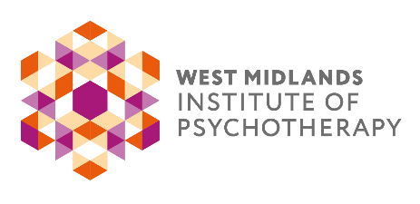

APPLICATION FORM

The Analytical Psychotherapy Training: Birmingham

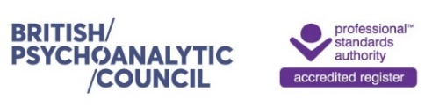in collaboration with

The Society of Analytical Psychology

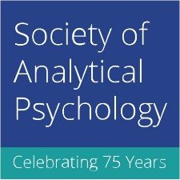

Presents on

Saturday 5th November 2022
Via Zoom Video Conferencing

JUNG’S “BOOK OF THE DEAD”:

ON DEATH AND DYING IN THE BLACK BOOKS
Sonu Shamdasani
AND

A COSMOLOGICAL DEVELOPMENT IN TIME:

THE INDIVIDUATION PROCESS IN THE LIGHT OF JUNG’S BLACK BOOKS
George Bright

Fees:

£60.00 - WMIP / SAP Members
£70.00 - Non-WMIP / Non-SAP Members

Your Details:

Title: Name:

Address:

Email: Telephone:

How did you hear about us?:
Your Work or Professional Body:

□ Please tick if WMIP Member / □ Please tick if SAP Member / □ Other Organisation ______________________

Do you require a certificate of attendance for CPD purposes?: Yes / No

Please make your payment by BACS as follows and return your completed form via email.

Bank: Barclays
Sort Code: 20-08-44
Account No: 03737950
Account Name: The Training in Jungian Analytical Psychotherapy
(Please use your name as a reference)

Alternatively send a cheque made payable to 'The Training in Jungian Analytical Psychotherapy' together with your completed form to:

Sue Harford, Administrator to the Training Committee
Unit 1A, West Stockwith Park, Stockwith Road
Misterton, Nottinghamshire. DN10 4ES

Cancellation Policy: All cancellations must be made in writing. Cancellations made no later than three weeks prior to the commencement of the lecture receive a full refund minus an administration fee of £10.00. Cancellations made within 3 weeks of the lecture will not be issued with a refund, but the fee paid can be allocated against a future public lecture.

If you are not a WMIP member, but would like to be kept informed of future events and short courses organised by WMIP committees and members, please delete yes / no below, to confirm how we may contact you.
Read our Privacy Notice at www.wmip.org.

Contact me by email: yes / no by phone: yes / no by post: yes / no

